**GROUP 5.9**

**Name - Rushikesh Nalla**

**ID - 201401106**

**Name - Omkar Damle**

**ID - 201401114**

**State Modeling**

**CENTRALISED SCHOLARSHIP MANAGEMENT SYSTEM**

**State Diagram for scholarship Application process :**

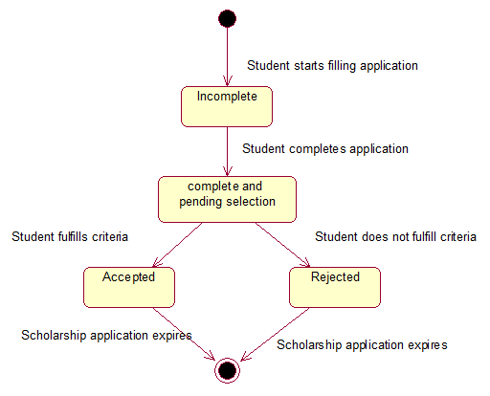

**State Diagram for scholarship class :**

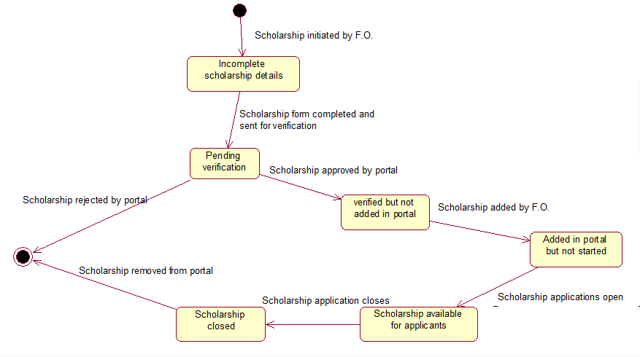

**State Diagram for Payment Transaction:**

